
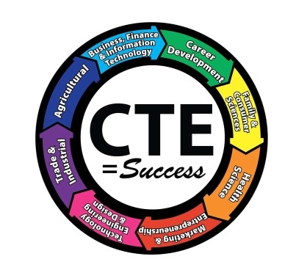
NC High School to Community College
Articulation Agreement

What is the Articulation Agreement?

This statewide articulation agreement is comprised of approximately 50 high school CTE courses that match the knowledge and skills taught in similar community college courses. The articulation agreement ensures that if a student is proficient in their high school course, the student can receive college credit for that course at any North Carolina community college. This streamlines the student’s educational pathway by eliminating the need to take multiple courses with the same learning outcomes.

In addition to this statewide articulation agreement, local articulation agreements can be developed to build strong partnerships between high schools and individual community colleges. These local articulation agreements respond to new and emerging industries, provide for programs unique to the region, and add additional articulated courses and pathway alignments at the local level that are not included in the state agreement.

How will the credit be awarded?

To receive articulated credit, students must enroll at the community college within two years of their high school graduation date and meet the following criteria:

Final grade of B or higher in the course, and;

A score of 93, or higher, on the standardized CTE Post assessment.

Community college officials verify eligibility and acceptance of articulated courses listed on the high school transcript. Students may be asked to submit supporting documentation and/or demonstrate proficiency to receive credit. Colleges must follow the criteria of the Southern Association of Colleges and Schools (SACS) Commission on Colleges in awarding credit.

What are some Benefits FOR TAKING THESE SPECIFIC CTE COURSES IN high School?

- Saves time- ability to earn more credits in less time towards a degree
- Saves Money– ABILITY TO EARN COLLEGE CREDITS while taking HIGH SCHOOL COURSES
- MEET prerequisites to advanced level college courses
- Already earned credit towards degree program

CTE courses at Wakefield High 2013-14, and before,
that articulate to Wake Technical Community College credits

WCPSS CTE course WTCC course number

Accounting I ACC 115 or ACC 118

Accounting II ACC 115 /118 or ACC 119

Horticulture I HOR 150

Horticulture II – Landscaping HOR 114 or LSG-111

Microsoft Word, Power Point and Publisher CIS 111 or 124 or OST 136

Multimedia and Webpage Design WEB 110 or 120

Personal Finance BUS 125

Early Childhood Education I AND ECE II EDU 119

Foods I AND Foods II, Enterprise CUL 112

Foods II, Technology CUL 150 AND CUL 150A

Health Science I MED 121 AND MED 122

Health Science II HSC 110 AND HSC 120 or MED 180

Entrepreneurship I ETR 210

Marketing ETR 230 or MKT 110 or MKT 120

Digital Media DME 110

Advanced Digital Media DME 115 or 120

Carpentry I CAR 110 or WOL 110 or CST 110

Carpentry II CST 111

Carpentry III CST 112

Computer Engineering Technology I CTS 120

Computer Engineering Technology II CTS 220

Drafting I DFT 111 AND DFT 111A

Drafting I AND Drafting II, Architectural DFT 115 or 119 or ACR 114

Drafting I AND Drafting II, Engineering DFT 151

Drafting III, Engineering DFT 112 AND DFT 112A

Network Engineering Technology I NET 125 or 110

Network Engineering Technology II NET 125 or 126

